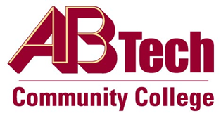

# Asheville-Buncombe Technical Community College (A-B Tech) Policy Manual

## Policy 705: Recruitment Publications and Presentations

It is the policy of the Board of Trustees that all recruitment materials and presentations represent Asheville-Buncombe Technical Community College accurately. No recruitment publication may be publicly distributed without the expressed, final approval of the Community Relations & Marketing Department.

## Scope

Applies to all student and employee recruitment at the College.

## Definitions

Recruitment: Includes both student and employee recruitment.

Student Recruitment: To actively encourage individuals to apply for admission and enroll in classes at the College.

Employee Recruitment: To actively encourage qualified individuals to apply for open employment positions at the College.

## References

Reviewed by the Executive Leadership Team, June 13 and 20, July 11, 2012

Reviewed by the Board of Trustees Executive Committee, July 19, 2012

## Policy Owner

President’s Office, Director of Community Relations & Marketing, Ext. 7900

See Recruitment Publications and Presentations Procedure

Approved by the Board of Trustees on August 6, 2012.